**Genii Analytics | Export Page | AQA**

V1. December 2020

Contents

General Icons 2

List of Assessments with Additional Commentary 3

List of Assessments with Output Metrics 5

List of Assessments with Output Metrics (Binary Version) 7

List of Assessments with Root Causes 8

List of Assessments with Coaching Feedback Comments 9

List of Assessments with Audit Details 10

Team Leader, Agent & Assessment Performance 11

UserRoles 12

Daily User Activity 13

Agent Metrics 15

Assessor Efficiency 16

General 17

# General Icons

Open Filter Icon



This icon will display your filter options per report. And will therefore have different selections options depending on your campaign configurations and the report selected.

Clear Filter icon



This icon will clear all existing filters selections and set all the default parameters.

The dates will default to the campaign set dates.

Info icon



This will show on some reports and it will display information like the default settings for the report you are on.

This icon may also contain a user guide.

# List of Assessments with Additional Commentary

This report will give you a tabular view of the data captured on the Call Details page as well Summary of Interaction and Additional Commentary data.

Each assessment will have one line of data.

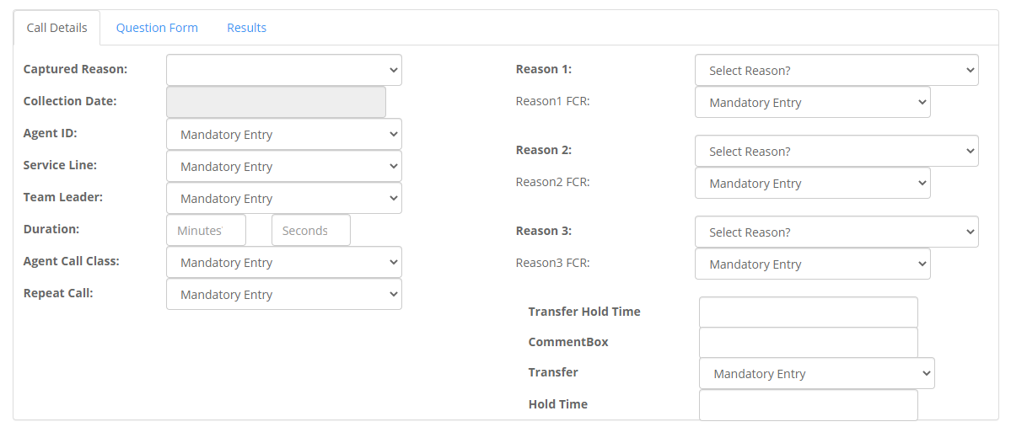

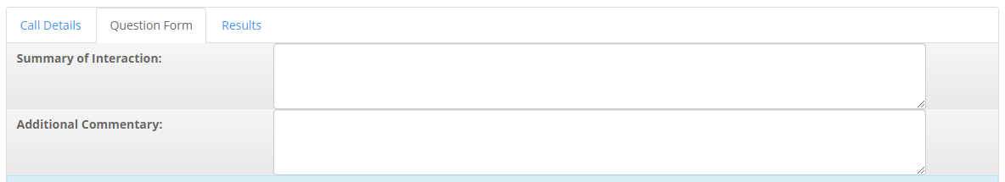

A view of one record of data

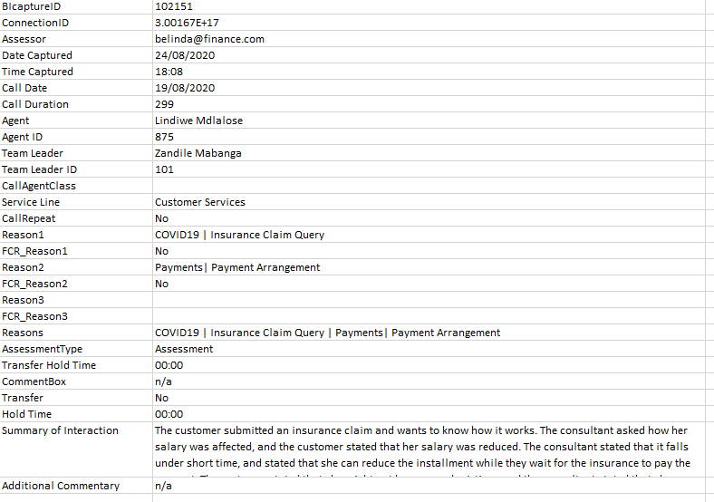

# List of Assessments with Output Metrics

This report will give you a tabular view of the data captured on the Call Details page as well as the results of your output metric questions (level 2).

Each assessment will have one line of data.

You can select to include the following

1. User Defined additions (this is the information captured below the Reason captures)

Example below

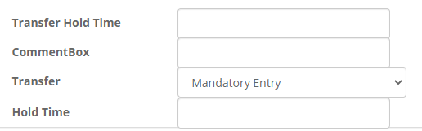

1. Main Comment boxes

You will also be able to view the output metric results as Yes or No.

It should be noted that Yes or No answers can mean either failures or accuracy depending on how the questions were set up.

A view of one record of data (Yes/No)

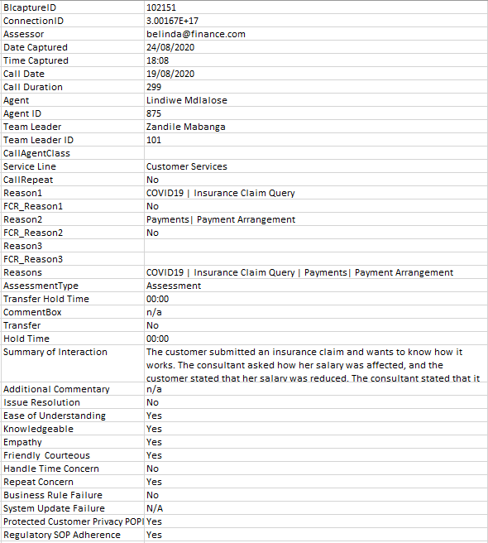

# List of Assessments with Output Metrics (Binary Version)

This report has the same data as the List of Assessments with Output Metrics report with the following variance.

1. Failures will display as 0 and Passes as 1. N/A as Hyphens.
2. The control type filter can be used to distinguish between agent, business, and insights.

A view of one record of data (1/0)

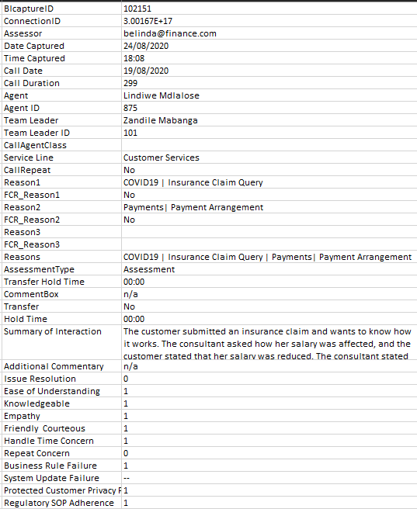

# List of Assessments with Root Causes

This view will give you all answers of an assessment.

Each assessment will display over multiple rows, depending on the questions answered

A view of one record of data

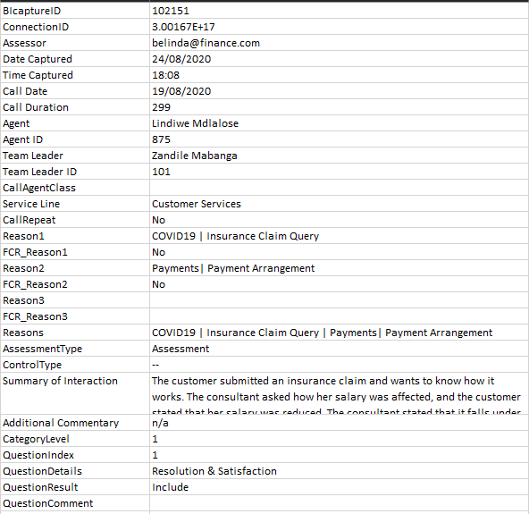

# List of Assessments with Coaching Feedback Comments

This report will give you a tabulated view of all the Feedback detail associated with an assessment.

Each assessment can display over multiple rows, depending on the number of feedback status capture.

A view of one record of data

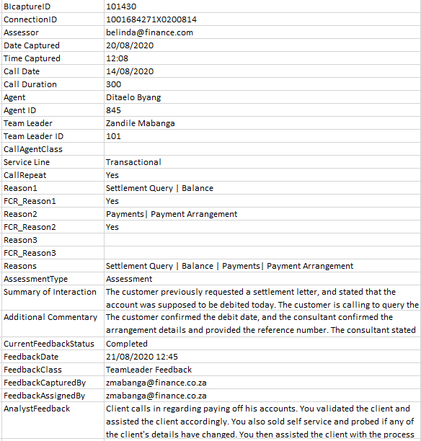

# List of Assessments with Audit Details

This report will give you a tabulated view of all the audits done on an assessment.

An assessment can have multiple lines depending on the actions performed.

It should be noted that Captures and Validations are also classified as Audits.

A view of one record of data

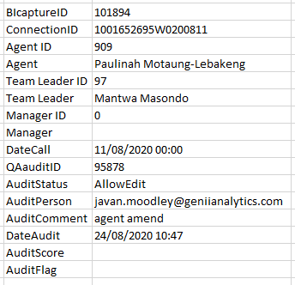

# Team Leader, Agent & Assessment Performance

This is a .csv version of the Team Leader Performance PDF Report, where the scores are displayed as either 100 or 0 %.

It gives the Controllable Section scores as well as the last feedback status and date.

A view of one record of data.

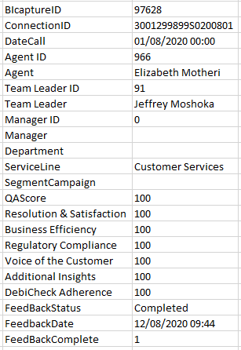

# UserRoles

Note not all user types may have access to this report.

This report gives you a tabular view of all users created on the app, including what access each user has.

A view of one record of data.

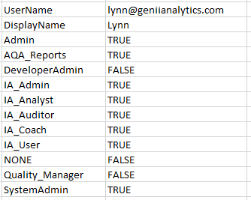

# Daily User Activity

This is a tabulated report showing the count of activities over time per user.

You can view as a summary as well as the count of each action

A view of one record of data

Summary

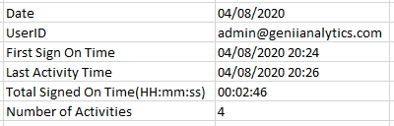

A view of one record of data

Detailed

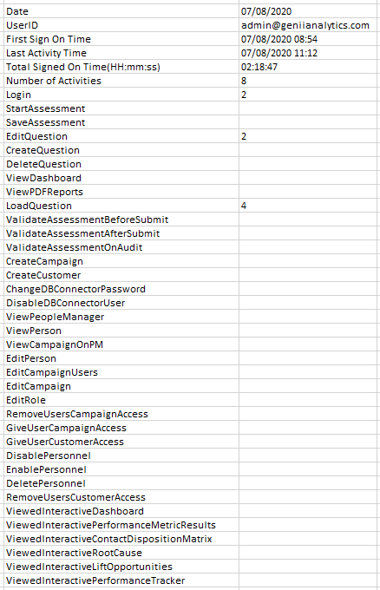

# Agent Metrics

This is a tabulated agent focused version of the Interactive Performance Metric Results.

Note that this report only notes the last date selected and give you 3 full months data from that date retrospectively.

A view of one record of data

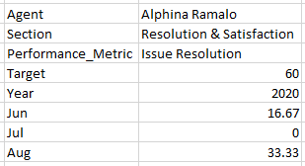

Report view

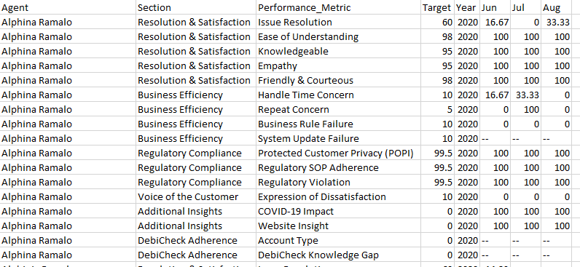

# Assessor Efficiency

This is a tabulated assessor focused report.

There are two reports, a daily summary, and an Efficiency detailed report

Efficiency % Calculation = (Interaction Duration) /(Action Duration - Interactive duration)

A view of one record of data

Daily Summary

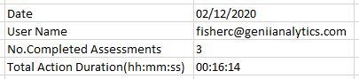

A view of one record of data

Efficiency detailed report

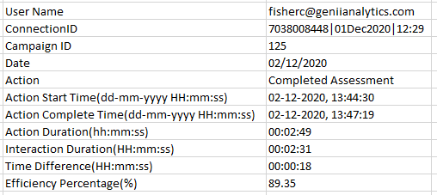

# General

Our dynamic filter is available on this page and will change according to the campaign settings.

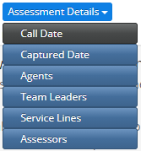

The Control Type filer is currently limited to a few exports. Please read the blurb on each report to see whether it is enabled on this report.

